Use-Case Realization Report(Design)
Delete Site

Issue <1.0>
Revision History
Date | Issue | Description | Author
29/11/09 | 1.0 | Initial Version | Rajendran Kumaraguru

Table of Contents
1. Brief Description 4
2. Flow of Events 4
3. Interaction Diagrams 4
3.1 Collaboration Diagram for Delete Site 4
3.2 Sequence Diagram for Delete Site 5
4. Participating Objects 5
5. Class Diagrams 6
5.1 Class Diagram for Delete Site 6
6. Derived Requirements 6

Use-Case Realization Report(Design)
Delete Site

Brief Description
When the company subscription is getting expired then the portal admin would be able to perform the deletion operation for the sites which is already created.

Flow of Events

Standard Flow
- Portal Admin login into the system.
- Select the site to be deleted.
- Validate fields will be validating the field data before proceeding to the deletion operation.
- Delete the site from the site.
- Upon deletion of the site system will show the success or failure to portal admin.

Exception Flow
  - If the lesson is not available for the selected lesson the exceptions message will be thrown to the user.
  - If there is any error while validating the field then respective error message will be shown to the portal admin
.

Interaction Diagrams

Sequence Diagram for Delete Site
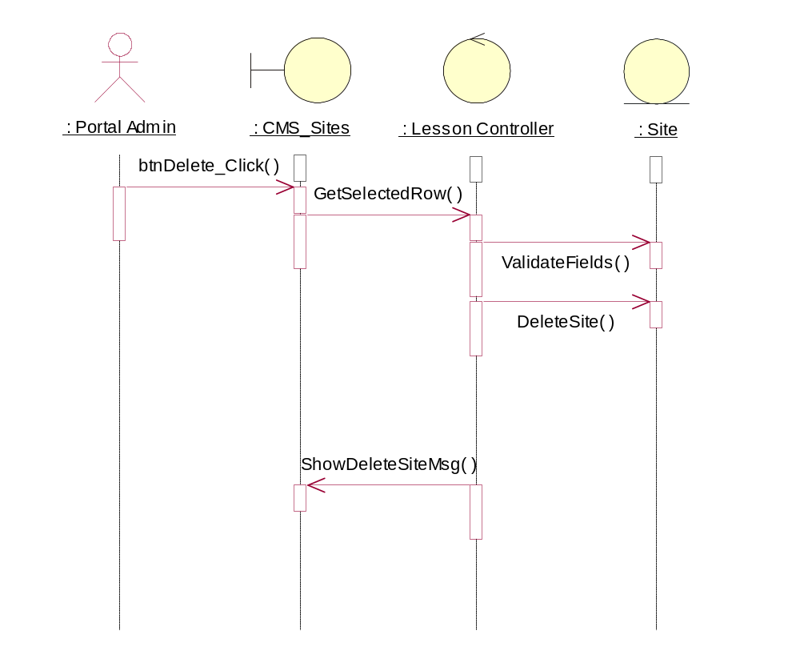

Participating Objects
: CMS_Sites

: Lesson Controller

: Portal Admin

: Site

Class Diagrams

Class Diagram for Delete Site
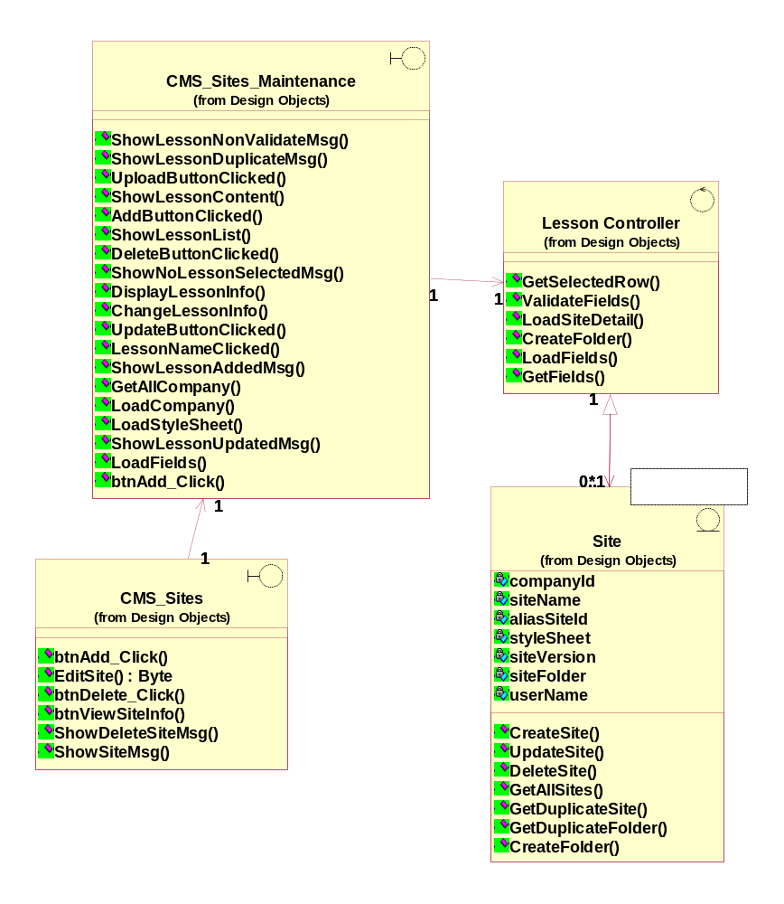

Derived Requirements
[enter the derived requirements here]

